Motorised adjustable railings
Layout
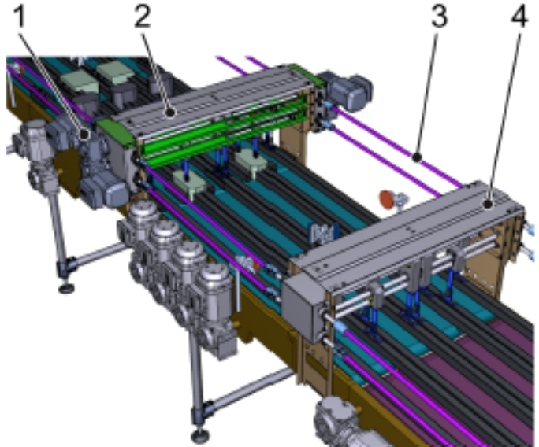

Figure 3-1: Automatic railing adjustment

Nº | Description
1 | Drive
2 | Railing bridge, active
3 | Transverse shaft
4 | Railing bridge, passive

Function
The railings are driven by up to four asynchronous motors. The drives are fitted to the sides of the railing bridge. The passive bridges are also driven by the transverse shafts.

